Title: **Binary Conversion and Timers** Worksheet: 3

Course: Introduction to Automation Unit: Introduction to PLC CLO: 4

Name ANSWER KEY Grade 32pts. Date ______________

**Objectives**

1. Student shall calculate a binary number given its equivalent value in decimal form.
2. Student shall calculate a decimal number given its equivalent value in binary form.
3. Student shall determine the state of timer output bits given specific information.

**Assessment**

Students shall demonstrate a comprehension of the objectives listed above by scoring a minimum of 75% on this Worksheet. Grading shall be based on the answer key.

**Instructions**

Convert the following decimal numbers to their binary equivalents.

1. 3310 0010 00012
2. 1110 0000 10112
3. 5110 0011 00112
4. 510 0000 01012
5. 12110 0111 10012
6. 1410 0000 11102
7. 8310 0101 00112
8. 910 0000 10012
9. 9910 0110 00112
10. 20110 1100 10012

**Instructions**

Convert the following binary number to the decimal equivalent.

1. 1010 1110 17410
2. 0010 1110 4610
3. 1001 1011 15510
4. 0111 1101 12510
5. 1011 1001 18510
6. 1001 1001 15310
7. 0111 1111 12710
8. 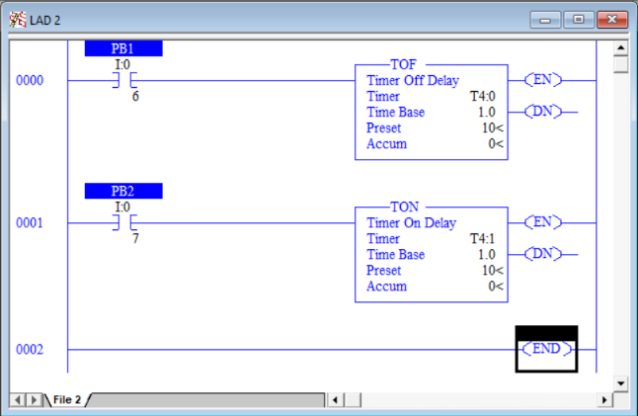0001 0010 1810
9. 0101 0001 8110
10. 1000 1010 13810

**Instructions**

Answer the following questions based on the ladder logic shown in the following program. PB1 is a NC pushbutton and PB2 is a NO pushbutton.

|  |  |
| --- | --- |
| If PB1 is pressed and the *Accum < Preset*;   1. What is the state of T4.0/DN?    1. True    2. False 2. What is the state of T4.0/TT? 3. True 4. False 5. What is the state of T4.0/EN? 6. True 7. False   If PB1 is pressed and the *Accum = Preset*;   1. What is the state of T4.0/DN?    1. True    2. False 2. What is the state of T4.0/TT? 3. True 4. False 5. What is the state of T4.0/EN? 6. True 7. False | If PB2 is pressed and the *Accum < Preset*;   1. What is the state of T4.1/DN? 2. True 3. False 4. What is the state of T4.1/TT? 5. True 6. False 7. What is the state of T4.1/EN? 8. True 9. False   If PB2 is pressed and the *Accum = Preset*;   1. What is the state of T4.1/DN? 2. True 3. False 4. What is the state of T4.1/TT? 5. True 6. False 7. What is the state of T4.1/EN? 8. True 9. False |